**实验报告：MATLAB在复变函数中应用**

姓名：陈闻天 学号：2023280259 日期：2024年12月23日

1. **实验目的**
2. Master how to calculate Complex Variable Function using Matlab
3. Learn to plot the figure of complex functions
4. **实验内容**

**Use Matlab to solve the following complex functions**

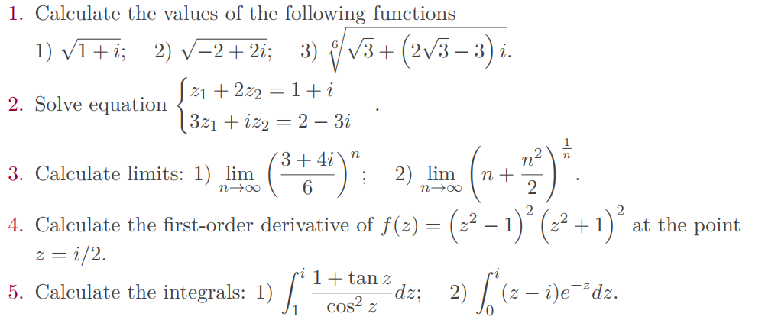

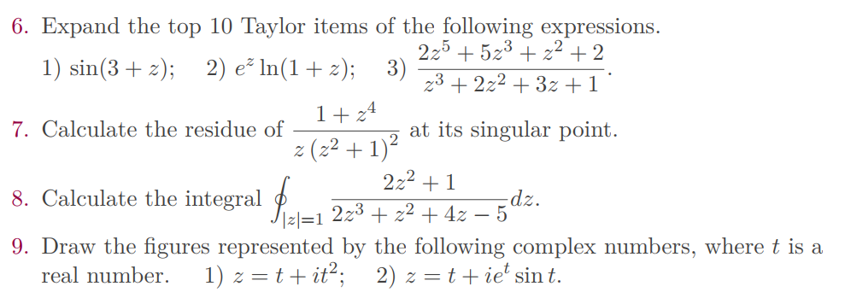

1. **实验代码与结果**

1. Calculate the values of the following functions

Code: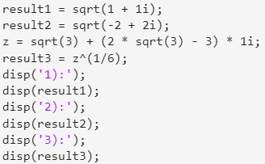 Result: 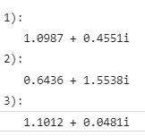

1. Solve equation

Code: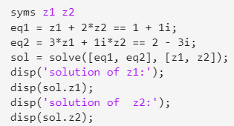 Result: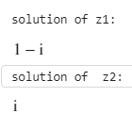

1. Calculate limit

Code: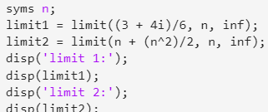 Result: 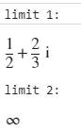

1. Calculate the first-order derivative

Code: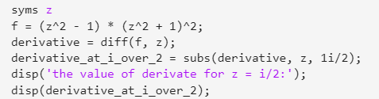

Result: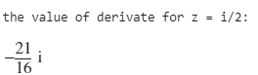

1. Calculate the integrals

Code: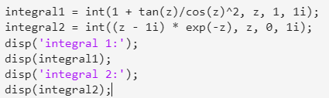

Result: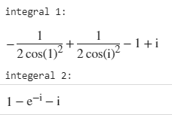

1. Expand the top 10 Taylor items of the following expressions

Code: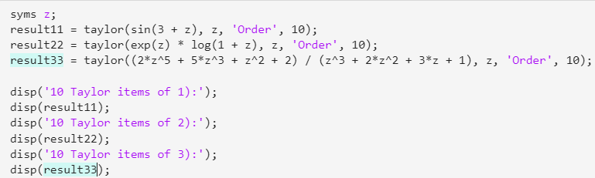

Result: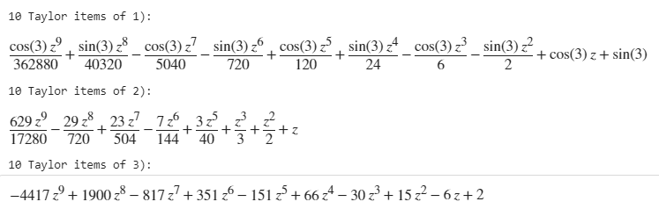

1. Calculate the residue

Code: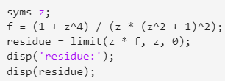

Result:

1. Calculate the integral

Code: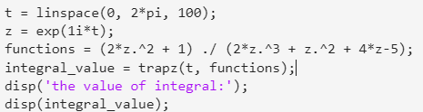

Result:

1. Draw the figures

Code: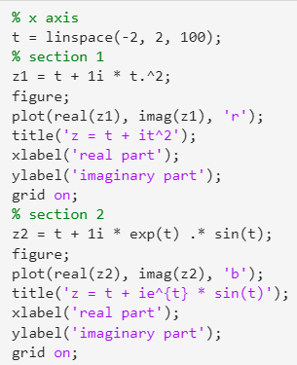

Result: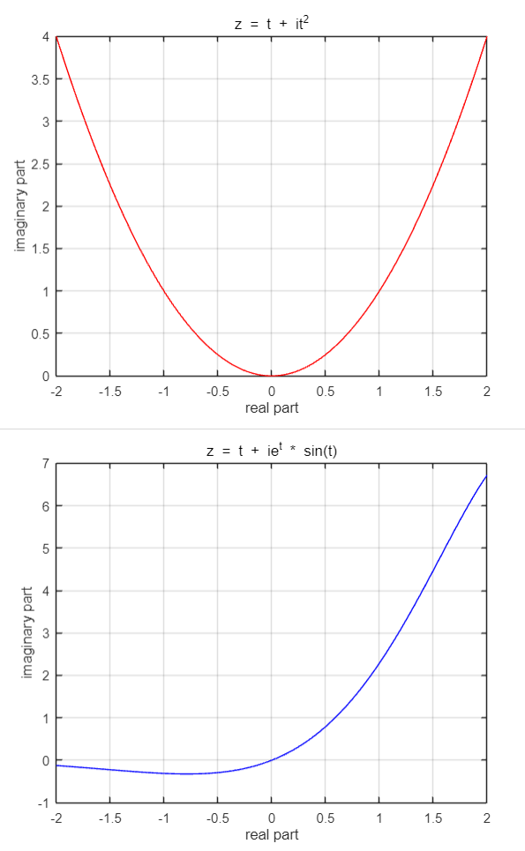

1. **实验总结**
2. We have learned how to calculate complex numbers, limit of complex functions, derivate of complex functions and so on using matlab API. After this experiment, we experience that it is easily to calculate complex functions if we use matlab API.
3. We experience the process of plotting figure of complex functions on the complex plane. Clear figure is useful for analysis.